**Product Requirements**

|  |
| --- |
| **Team Fourtran (f261-04d)** |

# Brief problem statement

We represent a funding group (Investiny Corp.) chartered to create applications for the benefit of communities all around the country. The product we envision is called Tool Share. At its core, Tool Share is meant to enable neighbors in a community to be able to share items of common use. The successful implementation should make it easy to anyone wanting to participate to register and be able to share or borrow items.

The Tool Share product is intended to improve communities by providing and easy mechanism for sharing items between neighbors. We envision this to primarily consist of tool exchanges but the implementation must be easily extended to include items of different kinds.

We want a product whose emphasis is on ease of use, whose navigation is straightforward and where the status of items and users is clearly displayed.

***Problem Statement:***

To allow members of a community to easily share items with each other. Neighbors that wish to participate shall register with the system and then be able to share and borrow items in their community. Tools would primarily consist of hardware, kitchen tools, and automotive tools, but these categories may be extended to different tools. Ease of use and straightforward navigation are of primary concern.

# Stakeholders

**Investiny Corp. Board of Directors** – oversee the projects funding and expenses. Have vested interest in the proven success of the product but are not involved in the planning and execution.

**Investiny Corp. Product Owner** – will act as principle representative for Tool Share product needs. He/she champions the product with the Board of Directors, helps facilitate product decisions and has the ultimate say on when and what features should be released.

**Software Engineering Team** – is responsible for the day-to-day operations and coordination of all aspects related to the software product's life-cycle. This include, among others: planning and delegation of team roles and responsibilities; elicitation and clarification of requirements; analysis and design; implementation, testing and release of all software components.

**Beta Testing Team** – represent the target user base for Tools Share. Will be available in later phases of the project to conduct acceptance testing and provide feedback on product release.

**End Users** – represent the actual user base for Tool Share. These users will receive support for official releases of the software, and will ultimately decide the success of the system.

# Users profile

The target user must:

- have basic experience using computers and browsing the internet. Has filled out online forms or surveys and may have purchased or sold a product.

- have access to a internet-connected computing device (equipped with a modern browser), either through ownership or a library, etc.

- have an interest in improving their community by lending or borrowing items of common use with others living near by

- have items to share and/or a desire to borrow items

- is willing to share information such as home address and contact information

- be a member of the community from which they wish to borrow

# System requirements

At a high-level this project will be source controlled in SVN, run on Django using python, sqlite and needs to be compatible with the latest browsers. jQuery wil be required for front end validation of form data.

Although the application needs to be accessible through the internet, deployments and demonstrations for this phase of the project will take place within the RIT Software Engineering environment. To this end, you must understand and document the target platforms from the perspective of the client browser as well as that of the server. Make sure to capture versions or software dependencies, programming languages and hardware specifications that are available for your use and proceed only after you document and confirm these with the customer.

# Feature requirements (user stories)

**Proposed Changes:**

* (1) Registration: Must provide X number of “tools” to share to community library.
* (4) Community Shed Creation: Community votes “Coordinator” of Shed

The following list of user stories is neither final nor comprehensive. You must consider it your responsibility to maintain it's relevance, clarify any misunderstandings and keep it up-to-date. Any changes must be discussed with the Product Owner for approval.

|  |  |  |  |
| --- | --- | --- | --- |
| **No.** | **User Story Name** | **Description** | **Release** |
| **1** | Registration | Registrant shall provide personal information and preferences to the System upon registering and becoming a User. (for example: Last name or Pickup Arrangements)  System will create a new Share Zone upon registration of User with previously unregistered zip code  Upon registration System will associate user with an already created Share Zone based on zipcode | R1 |
| **2** | Account Management - change personal info | User shall be able to change personal information after registration (for example: change address).  System will warn User if changing of community and effect any necessary changes to the item list. | R2B |
| **3** | Account Management - change user preferences | User shall be able to change preferences after registration (for example: email reminder frequency, pickup arrangements) | R2B |
| **4** | Community Shed creation | User shall be able to create a Shed for his Share Zone.  A Shed has a physical location where tools from several Users can be stored.  Shed creator becomes Coordinator of said shed. | R2 |
| **5** | Tool Management – registration | User can register a tool by providing items information. (for example: Picture, Category, Name, Description, Special instructions, etc.)  System will require a unique field to distinguish between similar tools (for example: two laser blasters but mine has “Buzz A 113” edged on its handle). Description field will be unique.  User must accept default Pickup Arrangement (set during User registration) or select a different arrangement for this tool (for example: “Please knock on my door” vs. “Let's make additional arrangements via email”) | R1 |
| **6** | Sharing – from Home | User can set a previously registered tool to be shared from home.  Tool cannot be shared from two places simultaneously  *User must physically have possession of tool prior to sharing it.*  User can change a previously registered tool | R2B |
| **7** | Sharing – from Community Shed | User can set a previously registered tool to be shared from a Community Shed.  Tool cannot be shared from two places simultaneously.  *User must physically move the tool to Shed prior to being allowed to share it.*  Shed Coordinator can, from time to time, verify and change status of tools in Community Shed (for example: a tool was returned but never marked as present or tool has gone missing) | R2 |
| **8** | Sharing – change location of tool | User can change a previously registered tool to be shared elsewhere.  System will prevent relocation when tool has an unresolved future reservation. | R2B |
| **9** | Sharing – change availability | User change availability of a tool. (for example: on black out dates when he/she will be using the tool, or be away/unwilling) | R2B |
| **10** | Sharing – approving a borrower | System will notify User upon a request to borrow his/her tool.  User owner of tool must approve the borrower when his/her tool is not at a Community Shed.  System will notify borrower of decision by owner and update tools status if necessary. | R2B |
| **11** | Tool Listing – availability | User can request from System a list of all tools and their availability. List shall be sorted by System.  Only tools in User's Share Zone will be visible | R2B |
| **12** | Borrowing - request | User can select to borrow a tool for specified days provided tool is available. Borrower can add a message to request.  User owner of tool will need to “Approve” or “Reject” the request to borrow unless tools is in a Community Shed were it is always automatically approved.  Upon approval, System will create Reservation with requested dates and update availability of a borrowed tool.  Upon rejection, owner of tool must provide a small reason for “Reject”.  System will send notification email to borrower or lender including reason or message where applicable. | R2B |
| **13** | Borrowing – arrangements | Borrower will receive an email and message when an owner accepts a request, this email/message will include instructions from Owner as to arrange pick up. | R2B |
| **14** | Borrowing - returning | Borrower will return tool pickup location unless otherwise agreed with tool owner.  *Borrower will notify the System that tool has been “Returned”*  User owner of tool will need to notify/acknowledge to the System that tool has been “Returned” unless request to borrow was made from a Community Shed were it will be acknowledged by Shed Coordinator.  System will update availability of a returned tool. | R2B |
| **15** | Tool Management – deregistration | User can deregister a tool they previously added to the System.  System will require confirmation in case of possible conflicts.  System will notify borrowers of tool being deregistered and update relevant information to disable availability of tool. | R2B |
| **16** | Tool Management – Status | User owner of tool can request from System a list of registered owned tools and their status. | R1 |
| **17** | Community Statistics | User can request a list of statistics for their specific Share Zone. Upon request System will verify association and display such listing.  Statistics that may be included:  - most active lenders  - most active borrowers  - most used tools  - most recently-used tools | R2 |
| **18** |  |  |  |

**6. Use case diagram:**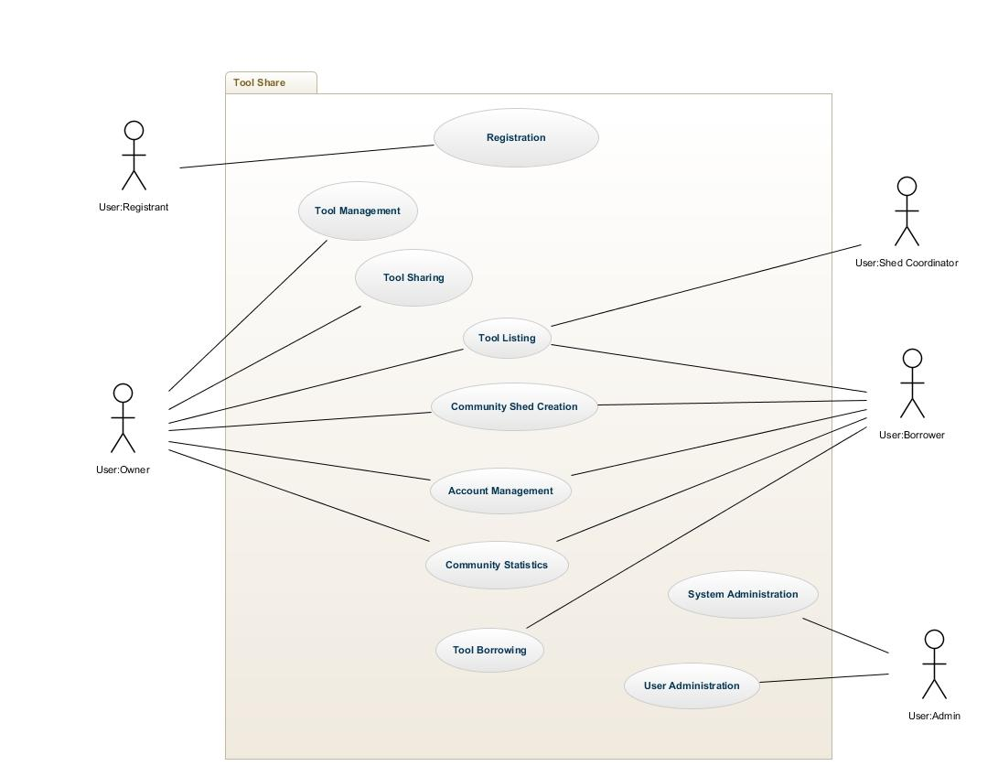

**7. Use case description**

|  |  |
| --- | --- |
| **Use Case Number:** | UC-01 |
| **Use Case Name:** | Registration |
| **Overview:** | Registrant shall provide personal information and preferences to the System upon registering and becoming a User. |
| **Actor(s):** | Registrant |
| **Pre condition(s):** | - System has been setup and configured.  - System is running and open for registrations.  - Registrant has accessed website via URL |
| **Scenario Flow:** | Main (success) Flow:   1. Registrant selects option to register 2. System requests personal information 3. Registrant provided personal information. 4. System verifies required information is provided.  * If information is invalid System displays message. Return to Step 2  1. System requests user's preferences 2. Registrant provides user preferences 3. System verifies required information is provided.  * If information is invalid System displays message. Return to Step 5  1. If user's zipcode is new to the System, new ShareZone is created 2. System will associate user with corresponding ShareZone 3. System displays confirmation of registration |
|  | **Alternate Flows:**  After Step(2) System will display the option to Cancel the registration process. The following steps would occur:   1. Registrant selects option to cancel during registration 2. System requests confirmation to cancel 3. Registrant confirms intent 4. System returns to main screen   **Post Condition:** Registrant did not complete registration. System does not store Registrant's information. |
| **Post Condition:** | User is registered with system and associated with a ShareZone. If the zipcode was new to the system, a new ShareZone was created. |

|  |  |
| --- | --- |
| **Use Case Number:** | UC-02 |
| **Use Case Name:** | Account Management |
| **Overview:** | User shall view and modify personal information and preferences stored by the system. |
| **Actor(s):** | Account Owner |
| **Pre condition(s):** | - System has been setup and configured.  - User has accessed website via URL  - User has successfully registered with the system |
| **Scenario Flow:** | Main (success) Flow:   1. User logs into system. 2. System requests username and password. 3. Systems verifies user’s credentials.    1. If information is invalid System displays message. Return to Step 2 4. System displays home screen. 5. User selects “edit preferences/information” 6. System displays user's preferences and personal information. 7. User edits preferences and personal information. 8. System verifies that preferences and personal information are valid.  * If information is invalid System displays message. Return to Step 5  1. If zipcode is changed and user's zipcode is new to the System, new ShareZone is created. 2. If zipcode is changed, System will associate user with corresponding ShareZone. 3. System displays confirmation of changes. |
|  | **Alternate Flows:**  After Step(3) System will display the option to reset the User’s password. The following steps would occur:   1. Registrant selects option to send a password reset link to the email on file for the account. 2. System requests confirmation to send the reset link. 3. Registrant confirms intent. 4. System returns to main screen.   **Post Condition:** User receives a password reset email.  After Step(5), the User may select to cancel changes. The following steps would occur:   1. System requests confirmation to cancel changes. 2. Registrant confirms intent. 3. System returns to main screen. |
| **Post Condition:** | **Post Condition:** No changes have been made to the User’s account.  User’s preferences have been changed. If the zipcode was changed, a new ShareZone may have been created, and the user is now associated with a new ShareZone. |

|  |  |
| --- | --- |
| **Use Case Number:** | UC-03 |
| **Use Case Name:** | Community Shed Creation |
| **Overview:** | User shall be able to create a Shed for his Share Zone. A Shed has a physical location where tools from several Users can be stored. Shed creator becomes Coordinator of said shed. |
| **Actor(s):** | User Owner, User Borrower |
| **Pre- condition(s):** | - System has been setup and configured.  - User has accessed website via URL  - User has successfully logged in |
| **Scenario Flow:** | Main (success) Flow:   1. System displays home screen. 2. User navigates UI to location to set up a Shed for his/her ShareZone. 3. User is prompted to enter information pertaining to Shed. 4. User enters Shed location. 5. User selects “Create Shed”. 6. User is prompted with message indicating Shed creation success and is navigated back to homepage. 7. User now sees a tab pertaining to this Shed and is notified of the title Coordinator of said Shed. 8. User is requested to enter any Shed tools owned by User for Shed storage. |
|  | **Alternate Flows:**  After Step(6), the User may select to cancel changes. The following steps would occur:   1. System requests confirmation to cancel changes. 2. Registrant confirms intent. 3. System returns to main screen.   **Post Condition:** No Community Shed is created. All data is discarded. |
| **Post Condition:** | A Community Shed is created and is now available. |

|  |  |
| --- | --- |
| **Use Case Number:** | UC-04 |
| **Use Case Name:** | Tool Management - Registration |
| **Overview:** | User can register a tool to be shared to the community. |
| **Actor(s):** | Account Owner |
| **Pre condition(s):** | User must be logged in. |
| **Scenario Flow:** | Main (success) Flow:   1. System displays home screen. 2. User navigates to “Tool Management” 3. User navigates to Register New Tool 4. System requests information about the tool 5. User input tool’s : picture(optional), category name, description, special instructions, quantity, status, and pickup arrangement. 6. System displays the Tool edit screen, and it is edited. 7. System verifies that the Tool registration is valid.    1. If information is invalid System displays message. Return to Step 5. 8. System asks for confirmation of Tool registration. 9. System displays confirmation of changes. |
|  | **Alternate Flows:**  After Step(3), the User may select to cancel changes. The following steps would occur:   1. System requests confirmation to cancel changes. 2. Registrant confirms intent. 3. System returns to main screen.   **Post Condition:** No tools registered. |
| **Post Condition:** | User’s tool has been registered. |

|  |  |
| --- | --- |
| **Use Case Number:** | UC-05 |
| **Use Case Name:** | Borrowing - request |
| **Overview:** | Account Owner request a member of the Tool Share community to share his or her tool. |
| **Actor(s):** | Tool Borrower and Tool Owner |
| **Pre condition(s):** | User must be logged into an account |
| **Scenario Flow:** | Main (success) Flow:   1. User navigates to Tool Library Tab 2. User selects tool to request sharing    1. this can be done via tool listing or by viewing a community member’s account.    2. User can add a small message to the request for the owner of the tool to see. 3. System marks the Tool as requested    1. Tool status is marked as requested for specified dates 4. System sends Tool owner a message to manage his or her tools 5. System receives confirmation to share tool 6. System updates tool to be be shared with the specified reserved time. |
|  | Alternate Flows:  In step 3 the user could select not to share the tool with the individual.   1. The user selects not to share the tool 2. The user to requested to borrow the tool is notified that the tool will not be shared. 3. System displays a mandatory form to fill out    1. The User has to explain why the request was denied. 4. System unmarks the tool as requested 5. System notifies the requester of the change with   Post Condition: Tool now shows has no information on the request. |
| **Post Condition:** | Tool can now not be be borrowed at the reserved time. |

|  |  |
| --- | --- |
| **Use Case Number:** | UC-06 |
| **Use Case Name:** | Tool Listing |
| **Overview:** | User can request from the System the list of tools and their availability. |
| **Actor(s):** | *Account owners* |
| **Pre condition(s):** | User must be logged into an account |
| **Scenario Flow:** | Main (success) Flow:   1. System Displays home Screen 2. User navigates to List Tools 3. System determines user’s Share Zone, and computes tool list 4. User views the list of tools his/her Share Zone |
|  | Alternate Flows:  After step 2, the search could find no tool in the area.   1. System notifies user of no tools found and prompts for a new share zone 2. Share Zone is updated and returns to step 3 of main flow   Post Condition: User has a list of tools in the share zone. |
| **Post Condition:** | Tools have been found in the area. |

|  |  |
| --- | --- |
| **Use Case Number:** | UC-07 |
| **Use Case Name:** | Tool editing - attributes |
| **Overview:** | User edits tool attributes |
| **Actor(s):** | Account Owner- Tool Owner |
| **Pre condition(s):** | User has successfully logged in. |
| **Scenario Flow:** | Main (success) Flow:   1. User navigates to Account management 2. User navigates Edit tools - attributes 3. User selects tool 4. System pulls tool’s attributes from database 5. User edits the tool    1. Status: If editing status calendar and unavailable is selected for a specific date with certain requests pending on said date, these requests go through the Denied Request process. 6. System validates the tool’s new attributes.    1. return to step 5 if invalid information is provided |
|  | Alternate Flows:  After Step(3), the User may select to cancel changes. The following steps would occur:   1. System requests confirmation to cancel changes. 2. Registrant confirms intent. 3. System returns to main screen.   **Post Condition:** No changes made. |
| **Post Condition:** | Tool attributes have been modified. |

|  |  |
| --- | --- |
| **Use Case Number:** | UC-08 |
| **Use Case Name:** | Tool Editing - Community Shed |
| **Overview:** | Shed Coordinator modifies tool status/attributes |
| **Actor(s):** | Shed Coordinator |
| **Pre condition(s):** | Shed Coordinator must be logged in |
| **Scenario Flow:** | Main (success) Flow:   1. User navigates to Shed Management. 2. System displays a list of tools contained in the shed 3. User selects tool 4. System pulls tool’s attributes from database 5. User edits the tool 6. System validates the tool’s new attributes.    1. return to step 5 if invalid information is provided |
|  | Alternate Flows:  After Step(3), the User may select to cancel changes. The following steps would occur:   1. System requests confirmation to cancel changes. 2. Registrant confirms intent. 3. System returns to main screen.   **Post Condition:** No changes made. |
| **Post Condition:** | Tool attributes have been modified. |

|  |  |
| --- | --- |
| **Use Case Number:** | UC-09 |
| **Use Case Name:** | Community Statistics |
| **Overview:** | User views community statistics for his Share Zone. |
| **Actor(s):** | User owner / User borrower / User shed coordinator |
| **Pre condition(s):** | User has logged in. |
| **Scenario Flow:** | Main (success) Flow:   1. System Displays home Screen 2. User navigates to Community Statistics. 3. System determines user’s Share Zone, and computes statistics. 4. System displays statistics. 5. User returns to main screen after viewing statistics. |
|  |  |
| **Post Condition:** | The user has viewed community statistics for his share zone. |

|  |  |
| --- | --- |
| **Use Case Number:** | UC-10 |
| **Use Case Name:** | Sharing - Approving a Borrower |
| **Overview:** | Tool Owner confirms a borrower’s request for a tool; a notification is sent to the requesting borrower. |
| **Actor(s):** | Tool Owner and Tool Borrower |
| **Pre condition(s):** | User has logged in. |
| **Scenario Flow:** | Main (success) Flow:   1. Home screen is displayed with a notification upon login. 2. User navigates to requests tab. 3. User selects pending request. 4. Information about the pending request is displayed. 5. User confirms request. 6. System changes status of tool from requested to reserved.    1. System sends notification to other pending borrowers asking for conflicting dates, if any. 7. System sends notification and e-mail to borrower. 8. Message is displayed to user to confirm the action. |
|  | Alternate Flows:  (Denied Request) Until Step(5), the User may select to Deny Requests. The following steps would occur:   1. System requests confirmation to deny request. 2. Registrant confirms intent. 3. System sends notification and e-mail to pending borrower.   **Post Condition:** No confirmation for specific . |
| **Post Condition:** | Tool attributes have been modified. |

|  |  |
| --- | --- |
| **Use Case Number:** | UC-14 |
| **Use Case Name:** | Borrowing - Returning |
| **Overview:** | User owner of tool can request from System a list of registered owned tools and their status. |
| **Actor(s):** | Tool Owner |
| **Pre condition(s):** | The Owner has an account and is on logged in on home page. |
| **Scenario Flow:** | **Main (success) Flow:**  1. The Borrower returns the tool to the location agreed upon with the owner  a. the default return location is the pickup location  2. The Borrower logs on and signs into their account and marks the tool as having been returned  3. The Owner signs into their home screen and receives a notification that the Borrower claims to have returned the tool  4. The Owner checks off that the tool has been returned |
|  | **Alternate Flows:**  1. The Owner checks off that the tool has not been returned.  2. The Borrower receives a notification that the tool has not been returned  **Postcondition:** the tool remains checked out |
| **Post Condition:** | The returned tool is marked as being available to be borrowed by the System |

|  |  |
| --- | --- |
| **Use Case Number:** | UC-15 |
| **Use Case Name:** | Tool Management - Status |
| **Overview:** | Borrower returns tool to an agreed upon location. The user and borrower then notify the system that the tool has been returned and the system updates the availability. |
| **Actor(s):** | Tool Owner and Tool Borrower |
| **Pre condition(s):** | The Owner and the Borrower each have an account and the Borrower is specified as having borrowed a tool. |
| **Scenario Flow:** | **Main (success) Flow:**  1. The Owner navigates to Edit Tools - Status.  2. The Owner views list of tools he owns with their current status from database next to it.  3. The Owner clicks on a tool and the tool’s calender is displayed in small pop-up window.  4. The Owner closes pop-up window and continues to look through tool list. |
|  | **Alternate Flows:**  After Step(3) the Owner may wish to immediately edit the tool he has the calender open for.  1. The Owner clicks on “Edit Tool” shortcut next to calender.  2. Continue to UC-8 Step(4).  **Postcondition:** Tool Owner has left Edit Tools - Status page |
| **Post Condition:** | Tool Owner is aware of his tool’s status’s. |

|  |  |
| --- | --- |
| **Use Case Number:** | UC-15 |
| **Use Case Name:** | Tool Management - Deregistration |
| **Overview:** | User deregisters a Tool they previously added to the System. The System will require confirmation in case of possible conflicts and will also notify borrowers of tool being deregistered and update relevant information to disable availability of tool. |
| **Actor(s):** | Tool Owner and Tool Borrower |
| **Pre condition(s):** | The Owner and the Borrower each have an account. The Owner has already registered a Tool and is logged in. |
| **Scenario Flow:** | **Main (success) Flow:**  1. The Owner navigates to Edit Tools.  2. The Owner views list of tools he owns and clicks a tool.  3. The Owner selects “Deregister Tool”.  4. The Owner receives a pop-up window asking for confirmation to deregister the Tool.  5. The Owner selects “Confirm Tool Deregistration”.  6. The Owner is returned to his list of tools that no longer contain the tool. |
|  | **Alternate Flows:**  After Step(3), if the Tool is currently being Borrowed, the Owner will be prompted to acquire possession of the Tool before being able to deregister tool.  1. The Owner receives a pop-up window informing him/her that to deregister a tool, an owner must be in possession of the tool.  2. The Owner is asked if he/she would like to send a message to the current Borrower/Shed Coordinator, asking to return the tool as soon as possible.  3. The Owner sends the request to the Borrower/Shed Coordinator and is returned to his/her list of tools with the tool still in the list.  **Postcondition:** Tool Owner has sent a Return Request message to Borrower. |
| **Post Condition:** | Tool Owner has deregistered the Tool. |